Analysis for SP and RJ

**Category level orders placed for SP and RJ**

Select e.customer_state,c.column2 as category, count(b.order_id) as orders from products a

Join items b

On a.product_id = b.product_id

join product_category_name_translation c

On a.product_category_name = c.column1

join orders d

On b.order_id = d.order_id

Join customers e

On d.customer_id = e.customer_id

group by c.column2, e.customer_state

Having e.customer_state = 'SP';

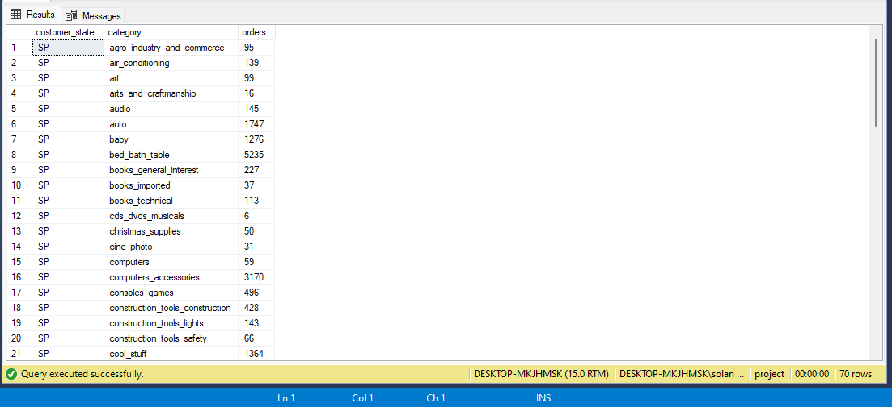

Select e.customer_state,c.column2 as category, count(b.order_id) as orders from products a

Join items b

On a.product_id = b.product_id

join product_category_name_translation c

On a.product_category_name = c.column1

join orders d

On b.order_id = d.order_id

Join customers e

On d.customer_id = e.customer_id

group by c.column2, e.customer_state

Having e.customer_state = 'RJ';

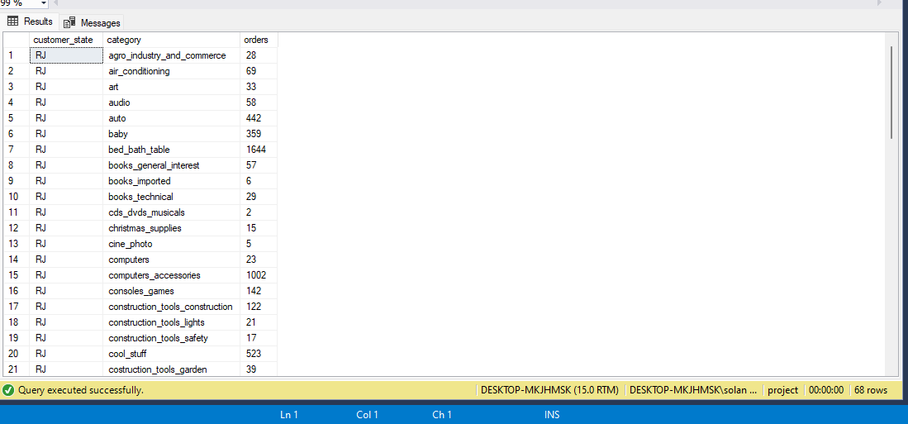

**Analysis of orders delivered before and after the expected date for SP and RJ**

select count(*) as delay from orders a

Join items b

On a.order_id = b.order_id

Join customers d

On a.customer_id = d.customer_id

Join reviews e

On a.order_id = e.order_id

where customer_state like 'RJ' and datediff(day,a.order_estimated_delivery_date,a.order_delivered_customer_date) > 0;

select count(*) as before_time from orders a

Join items b

On a.order_id = b.order_id

Join customers d

On a.customer_id = d.customer_id

Join reviews e

On a.order_id = e.order_id

where customer_state like 'RJ' and datediff(day,a.order_estimated_delivery_date,a.order_delivered_customer_date) <= 0;

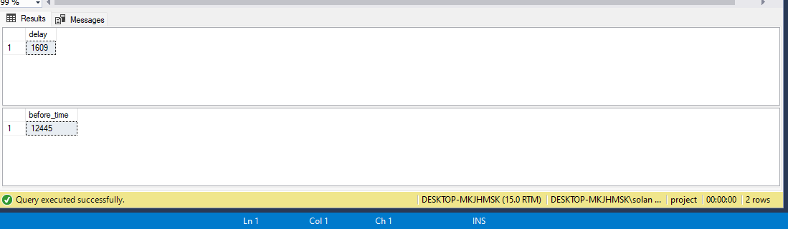

select count(*) as delay from orders a

Join items b

On a.order_id = b.order_id

Join customers d

On a.customer_id = d.customer_id

Join reviews e

On a.order_id = e.order_id

where customer_state like 'SP' and datediff(day,a.order_estimated_delivery_date,a.order_delivered_customer_date) > 0;

select count(*) as before_time from orders a

Join items b

On a.order_id = b.order_id

Join customers d

On a.customer_id = d.customer_id

Join reviews e

On a.order_id = e.order_id

where customer_state like 'SP' and datediff(day,a.order_estimated_delivery_date,a.order_delivered_customer_date) <= 0;

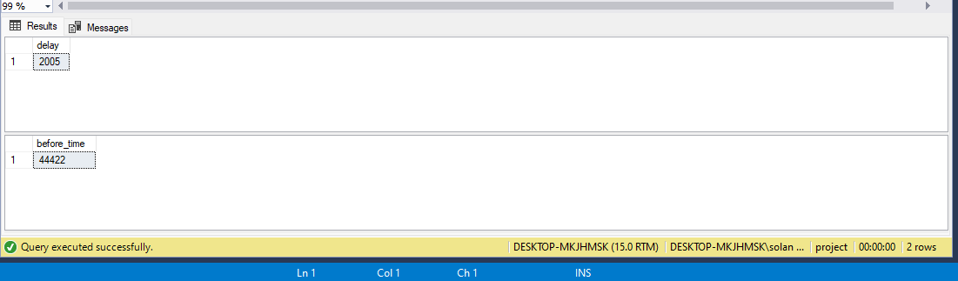

**Delay in shipping by the sellers for RJ and SP**

select count(*) as delay

from orders a

Join items b

On a.order_id = b.order_id

Join sellers c

On b.seller_id = c.seller_id

Join customers d

On a.customer_id = d.customer_id

where customer_state like 'SP' and datediff(day,b.shipping_limit_date,a.order_delivered_carrier_date) > 0;

select count(*) as before_time

from orders a

Join items b

On a.order_id = b.order_id

Join sellers c

On b.seller_id = c.seller_id

Join customers d

On a.customer_id = d.customer_id

where customer_state like 'SP' and datediff(day,b.shipping_limit_date,a.order_delivered_carrier_date) <= 0;

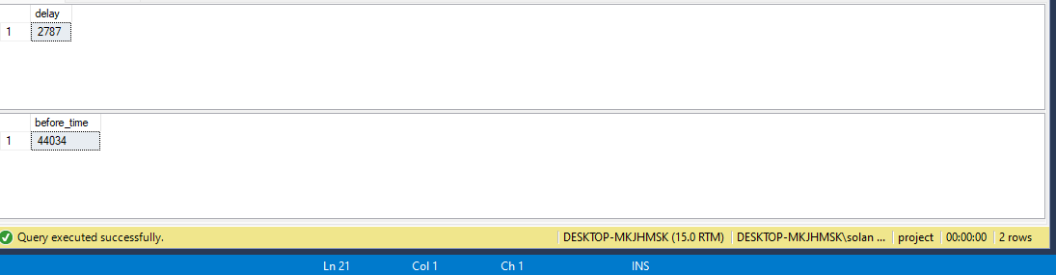

select count(*) as delay

from orders a

Join items b

On a.order_id = b.order_id

Join sellers c

On b.seller_id = c.seller_id

Join customers d

On a.customer_id = d.customer_id

where customer_state like 'RJ' and datediff(day,b.shipping_limit_date,a.order_delivered_carrier_date) > 0;

select count(*) as before_time

from orders a

Join items b

On a.order_id = b.order_id

Join sellers c

On b.seller_id = c.seller_id

Join customers d

On a.customer_id = d.customer_id

where customer_state like 'RJ' and datediff(day,b.shipping_limit_date,a.order_delivered_carrier_date) <= 0;

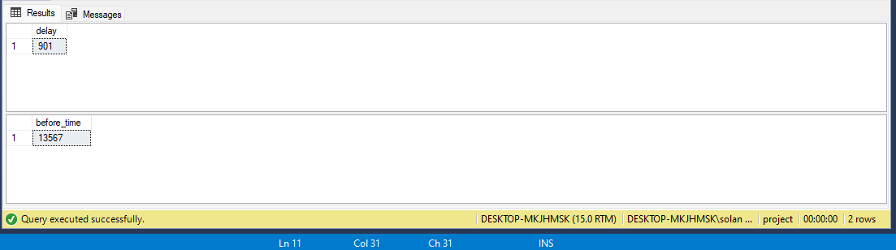

Cities with orders placed per year for SP and RJ

Select e.customer_state,e.customer_city,datepart(year,d.order_delivered_customer_date) as Year, count(b.order_id) as orders from products a

Join items b

On a.product_id = b.product_id

join product_category_name_translation c

On a.product_category_name = c.column1

join orders d

On b.order_id = d.order_id

Join customers e

On d.customer_id = e.customer_id

group by e.customer_state, e.customer_city,datepart(year,d.order_delivered_customer_date)

Having e.customer_state = 'RJ'

Order by count(b.order_id) desc;

Select e.customer_state,e.customer_city,datepart(year,d.order_delivered_customer_date) as Year, count(b.order_id) as orders from products a

Join items b

On a.product_id = b.product_id

join product_category_name_translation c

On a.product_category_name = c.column1

join orders d

On b.order_id = d.order_id

Join customers e

On d.customer_id = e.customer_id

group by e.customer_state, e.customer_city,datepart(year,d.order_delivered_customer_date)

Having e.customer_state = 'SP'

Order by count(b.order_id) desc;

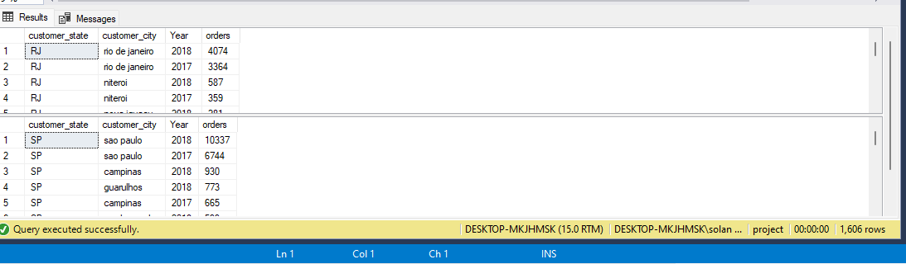

Cities with max delayed orders for SP and RJ

select d.customer_state,d.customer_city,datediff(day,a.order_estimated_delivery_date,a.order_delivered_customer_date) as delay,

sum(count(*)) over(partition by d.customer_city) as total_delayed_orders

from orders a

Join items b

On a.order_id = b.order_id

Join customers d

On a.customer_id = d.customer_id

Join reviews e

On a.order_id = e.order_id

group by d.customer_state,d.customer_city,datediff(day,a.order_estimated_delivery_date,a.order_delivered_customer_date)

having customer_state like 'RJ' and datediff(day,a.order_estimated_delivery_date,a.order_delivered_customer_date) > 0

order by sum(count(*)) over(partition by d.customer_city) desc;

select d.customer_state,d.customer_city,datediff(day,a.order_estimated_delivery_date,a.order_delivered_customer_date) as delay,

sum(count(*)) over(partition by d.customer_city) as total_delayed_orders

from orders a

Join items b

On a.order_id = b.order_id

Join customers d

On a.customer_id = d.customer_id

Join reviews e

On a.order_id = e.order_id

group by d.customer_state,d.customer_city,datediff(day,a.order_estimated_delivery_date,a.order_delivered_customer_date)

having customer_state like 'SP' and datediff(day,a.order_estimated_delivery_date,a.order_delivered_customer_date) > 0

order by sum(count(*)) over(partition by d.customer_city) desc;

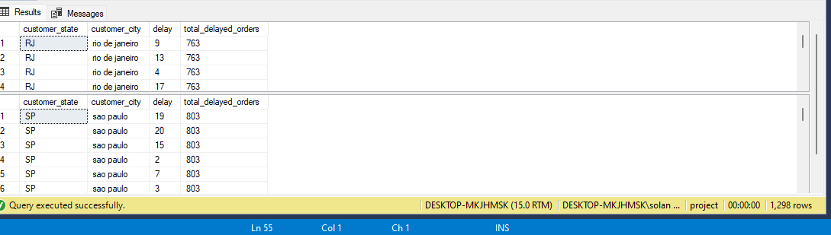

**We see that rio de janeiro is the city that sets the trend for RJ in terms of maximum number of orders and also delayed orders**

**Sao Paulo sets the trend for AC in terms of max number of orders and delayed orders**